SEASONAL FAVORITES
Peary Cobbler 9
St George Spiced Pear Liqueur, Deep Eddy Lemon Vodka, Simple Syrup
Maple Crush 12
Knob Creek Smoked Maple Bourbon, Orange Juice, w/ a Splash of Sprite
Drunkin Pumpkin 9
Fulton’s Harvest Pumpkin Pie Cream Liquor, Cruzan Vanilla Rum, topped with whipped cream & cinnamon
Autumn Cran-Apple Mule 10
Jim Beam Apple, Fever Tree Ginger Beer, Cranberry Juice & fresh Lime Juice
Chocolate Expresso Martini 12
Luxardo Expresso Coffee Liqueur, Lico 43 Chocolate Liqueur, Pinnacle Vanilla Vodka
Warm & Toasty
Hot Apple Cider, Coffee or Hot Chocolate, Spiked with your Favorite Spirit
“2 IDIOTS” SPECIALTIES
Named after our 2 Favorite Idiots, Jason & Craig who continue to surprise us with their creative cocktail creations

“2 Idiots” Peach Cobbler Smash 10
Jim Peach, Cruzan Rum, Fireball, Fresh Peaches, & Peach Puree
“2 Idiots” Old Fashioned 9
2 Gingers Irish Whisky, Muddled Orange Slices, Cherries with a splash of Apple Cider & Bitters
“2 Idiots” Malibu Barbie 9
Malibu Rum, Peach Puree, Sprite w/ fresh lime
“The Idiot” for Idiot #1 15
2-Fingers of 2 Gingers Irish Whisky served in a 2 Idiots glass you can take home.
SPARKLING
Aperol Spritz 9
Aperol & Silvergate Brut, w/ a splash of Club Soda
Sparkling Peach or Strawberry Belini 9
Made with Silvergate Brut
French 75 9
Bombay Gin, Fresh Lemon Juice, Simple Syrup & Silvergate Brut
CLASSICS
Basil Hayden Sidecar 14
Basil Hayden Bourben Whisky, Gran Marnier & fresh squeezed Lemon Juice
Dirty Shirley 10
44 North Cherry Vodka, Sprite w/ a splash of Grenadine & Cherries
OLD FAVORITES
Boozy Tea 10
Jim Beam Peach, Elderflower Liqueur, Simple Syrup with your choice of Sweet or Unsweet Iced Tea
Blood Orange Crush 10
Sky Blood Orange Vodka, Grand Marnier, Orange Juice w/ a Splash of Sprite
Enchanted Cosmo 10
Tito’s Vodka, Elderflower Liqueur, Peach Schnapps, Lime & Cranberry Juice
Coconut Pineapple Sunrise 10
Rum Chata Coconut Cream Liqueur, Rum, Pineapple Juice & Grenadine
MARGARITAS
* Tequila Tuesday Price
Tidewater Grille Margarita 14/12*
Patron Reposado Tequila, Triple Sec & Lime Juice, Sour & Topped w/ Grand Marnier
Cucumber Jalapeno Margarita 12/10*
21 Seeds Cucumber Jalapeno Tequila, Jalapino Infused Simple Syrup, Lime Juice & Agave
Pomegranate Margarita 14/12 *
Casa Noble Reposado Tequila, Pama Pomegranate Liquor, Triple Sec, Lime Juice & Sour
Autumn Rita 12/10*
21 Seeds Valencia Orange Tequila, Apple Cider, Orange Juice & Simple Syrup
Pineapple Margaita 14/12*
Casa Noble Blanco, Triple Sec, Fresh Squeezed Lime Juice, Jarritos Pineapple Soda
w/ a Chamoy rimmed glass
Cantaritos 14/12*
Casamigos Repasado, Agave, Orange Juice, fresh squeezed lemon & Lime Juice, Jarritos Grapefruit Soda w/ a Chamoy rimmed glass
Paloma Margarita 12/10*
21 Seeds Grapefruit Hibiscus Tequila, Fresh squeezed Lime Juice, Grapefruit Juice, Jarritos Grapefruit Soda in a salt rimmed glass
TEQUILA FLIGHT OF THE MONTH $23.00
Sample 4 shots of the featured Tequila for the month. Flight will include: Blanco, Reposado, Anejo & Extra-aged.
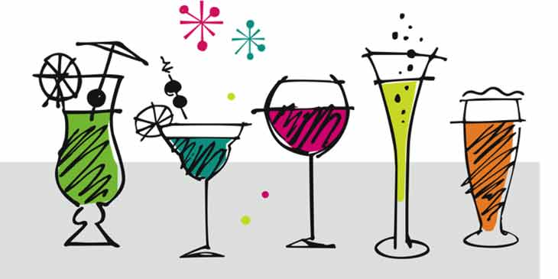

All Alcohol Sales are Final

